11/12/2019

ACME Entertainment Pty Ltd

South Metropolitan TAFE

Software Development Master Document

Rapid Application Development

Table of Contents

Sprint One 3

Meeting Minutes 3

External Meeting with Client 3

Internal Meeting 3

Source Control 3

Project Management Plan version 1 3

Software Development Testing Plan 3

Overview 3

Functional and Regression Testing 3

GUI and Usability Testing 3

Accessibility Testing 3

Compatibility Testing 3

Performance Testing 3

Installation / Configuration Testing 3

System Integration Testing (SIT) 3

Security Testing 3

Internationalization / Localization Testing 3

User Acceptance Testing (UAT) 3

Testing Table 3

Screenshot 3

Bibliography 3

Glossary of Term 3

Analysis documentation 3

CITE Business Rules for Software Development 3

The Common Aspects of CITE Coding Standard: 3

The following “ 3

CITE Managed Service Quality Assurance 3

Quality Management Services’ Tasks and Objectives 3

Comprehensive Approach to Quality 3

Independent QA Department 3

Quality Assurance Life Cycle 3

ACME Entertainment Pty Ltd development requirements 3

Bibliography 3

Glossary of Term 3

# Sprint One

## Meeting Minutes

### External Meeting with Client

ACME Entertainment Pty Ltd

|  |  |
| --- | --- |
| Present: | Jayden Lee, Daniel Hee, Tze Hon, Stewart Godwin (Client) |
| Date | Time: | 5 November 2019, 09:00 AM |

1. Purpose of this meeting

This is a meeting between the team members and the client. The purpose of this meeting it to identify the client needs and requirement.

1. Requirement#1 – Have a Source Control

* Identify which source control program to use
* Upload all documentation or report for Sprint One
* Have version control – this will records changes to a file

1. Requirement#2 – Have a Project Management Plan

* List out all the Task for Sprint One
* Have version control – this will allow the client to keep track on the progress
* Provide a time frame for each task
* List out which team member is responsible on which task

1. Requirement#3 – Have a Software Development Testing Plan

* List out all possible testing agenda
* Ensure all testing agenda met the requirement
* Ensure this plan will includes the Quality Assurance standards of CITE

1. Requirement#4 – Documentation should be formatted properly

* Ensure all documentation have the same fonts, heading, font size.
* Ensure all documentation have table of contents, reference, and glossary of term (if needed).

1. Requirement#5 – Have a Multi-Platform Report (Adaptive v Responsive)

* Explain Adaptive and Responsive Design
* Comparison between both design
* Recommendation whether to choose Adaptive or Responsive design for the site

### Internal Meeting

ACME Entertainment Pty Ltd

|  |  |
| --- | --- |
| Present: | Jayden Lee, Daniel Hee, Tze Hon |
| Date | Time: | 5 November 2019, 11:30 AM |

1. Purpose of this meeting

This is an internal meeting between the team members. The purpose of this meeting is to identify the project parameters and allocate work to each team member.

1. Team Member#1 – Daniel Hee

This team member will have the following roles:

* Present Sprint One to the Client
* Provide a Report regarding the Multi-Platform which are Responsive and Adaptive Web Design
* Cascading Sheet Styles (CSS) Formatting for the site after deciding which types of web design to implement
* Provide Comment on Code and Code Modularity

1. Team Member#2 – Jayden Lee

This team member will have the following roles:

* Provide a project management plan for our project
* Cascading Sheet Styles (CSS) Formatting for the site after deciding which types of web design to implement
* Provide a Software Development Testing Plan which includes the Quality Assurance standards of CITE
* Provide full term of acronyms found in any report

1. Team Member#3 – Tze Yee Hon

This team member will have the following roles:

* Provide an analysis report
* Cascading Sheet Styles (CSS) Formatting for the site after deciding which types of web design to implement
* Format Template or Report’s fonts, sizes, heading, Table of Contents, etc

## Source Control

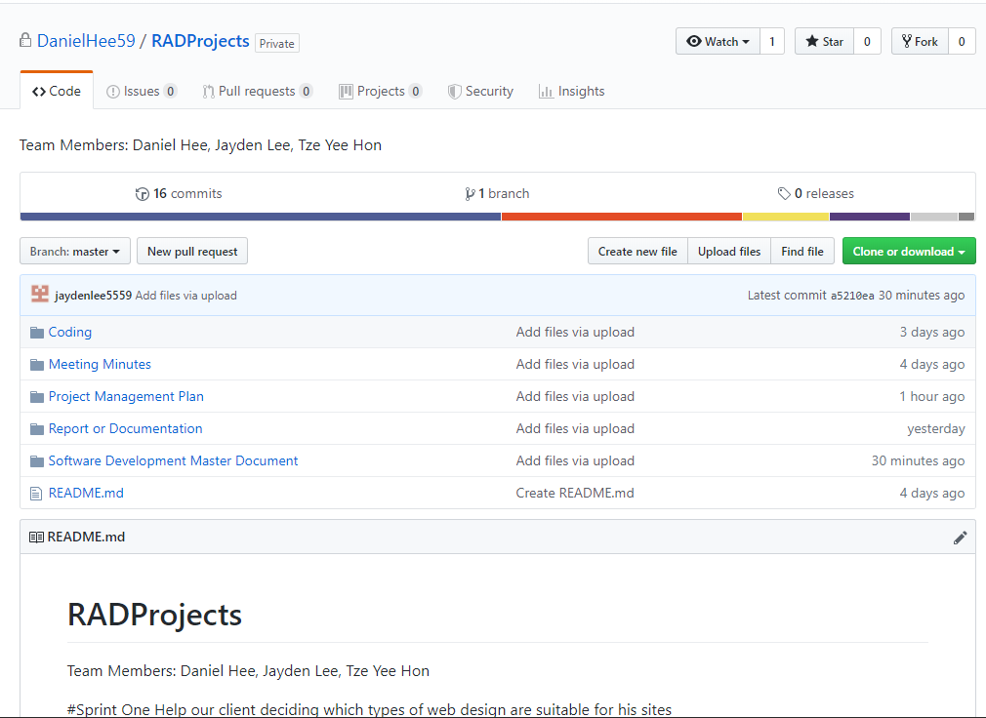

## Project Management Plan version 1

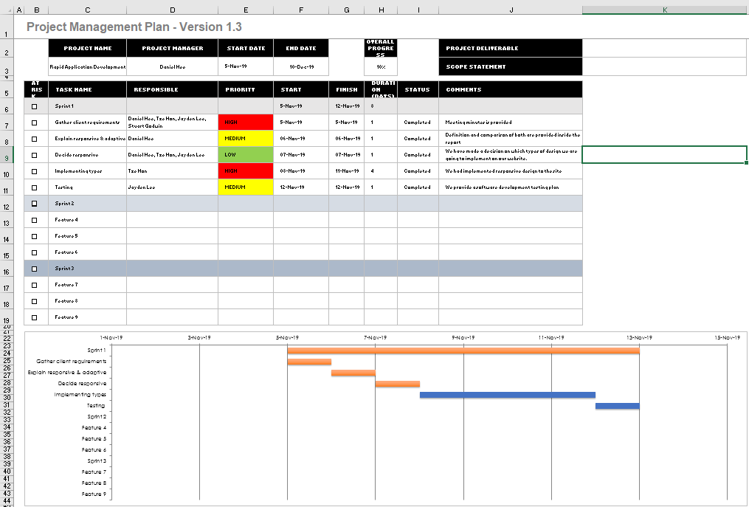

## Software Development Testing Plan

### Overview

This Software Development Testing Plan (SDTP) is used to test out the features and functionality of the Responsive Design website according to the CITE Quality Assurance as below:

### Functional and Regression Testing

**Functional testing** is performed to ensure all functionalities of an application is working as expected.

**Regression testing** is performed once a build is released to check the existing functionality. (360 Logica, n.d.)

### GUI and Usability Testing

**Usability Testing** is focused on the end user and checks the impressions of the application usage.

**GUI Testing** is performed on various platforms in order to check the look and feel of the application.

(Professional QA, n.d.)

### Accessibility Testing

Performed to ensure that the application being tested is usable by people with disabilities like hearing, color blindness, old age and other disadvantaged groups.

(Guru 99, n.d.)

### Compatibility Testing

Check whether the software is capable of running on different hardware, operating systems, applications, network environments or Mobile devices.

(Guru 99, n.d.)

### Performance Testing

**Performance testing** is the process of determining the speed, responsiveness and stability of a computer, network, software program or device under a workload.

(Guru 99, n.d.)

### Installation / Configuration Testing

Test the performance of a software product on a machine with different hardware or software configurations namely, operating system, browser, supported drivers.

(Guru 99, n.d.)

### System Integration Testing (SIT)

Carried out in an integrated hardware and software environment to verify the behavior of the complete system. It is testing conducted on a complete, integrated system to evaluate the system's compliance with its specified requirement.

(Wikipedia, n.d.)

### Security Testing

Ensures software systems and applications are free from any vulnerabilities, threats, risks that may cause a big loss.

(Guru 99, n.d.)

### Internationalization / Localization Testing

**Internationalization** is making the application such that it supports multiple languages/locales.

**Localization** is making an application support a particular locale and language.

(Software Testing Help, n.d.)

### User Acceptance Testing (UAT)

Last phase of software testing, users test the software to make sure it can handle required tasks in real-world scenarios, according to specifications.

(Techopedia, n.d.)

### Testing Table

|  |  |  |  |  |
| --- | --- | --- | --- | --- |
| Case No | Test types | Description | Status | Evidence |
| 1 | Functional and Regression Testing | All the functions are works perfectly | Tested | Figure 1 – 4 |
| 2 | GUI and Usability Testing | The website has navigation bar, text boxes and buttons to go thru | Tested | Figure 2.1 |
| 3 | Accessibility Testing | Doesn’t have any functions for disadvantages group such as deaf/blind, disabilities people. | N/A | N/A |
| 4 | Compatibility Testing | Is compatible for different platforms such as laptop, mobiles, and computers, tablets. | Tested | Figure 3 |
| 5 | Performance Testing | No workload is applicable in this testing | N/A | N/A |
| 6 | Installation / Configuration Testing | Work well on different operating system, browsers | Tested | Figure 1 |
| 7 | System Integration Testing (SIT) | Data exchanges (data import/export) happens between the system components (MySQL & HTML/PHP) and then the behavior of each data field within the individual layer is examined. | Tested | Figure 4 |
| 8 | Security Testing | Security features likes authorization credentials isn’t implemented in this project | N/A | N/A |
| 9 | Internationalization / Localization Testing | Its only available in English languages | N/A | N/A |
| 10 | User Acceptance Testing (UAT) | End users testing with the basic functions of searching movies, show all movies, and top 10 movies | Tested | Figure 1 – 4 |

### Screenshot

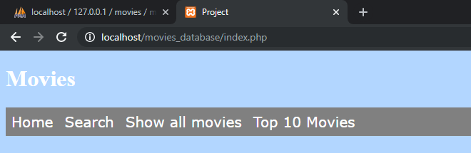

Figure 1.1 Google Chrome browser

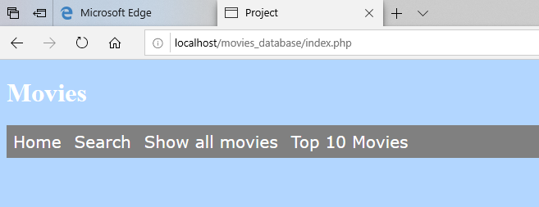

Figure 1.2 Microsoft Edge browser

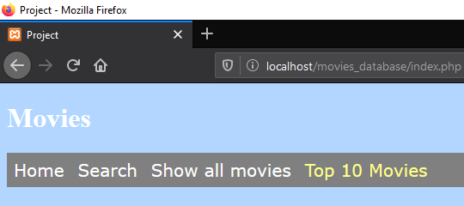

Figure 1.3 Mozilla Firefox browser

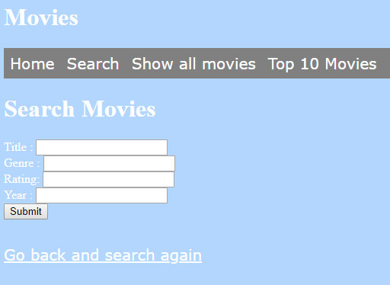

Figure 2.1 – GUI – Navigation bar, text boxes, buttons, and hyperlinks

  
Figure 3.1 – iOS Mobile landscape mode

  
Figure 3.2 – iOS Mobile portrait mode

  
Figure 3.3 – iOS tablet landscape mode

  
Figure 3.4 – iOS tablet portrait mode

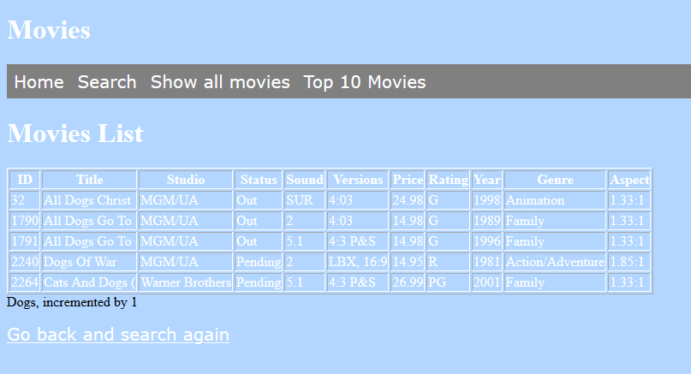

Figure 4.1 – Search function works well with database

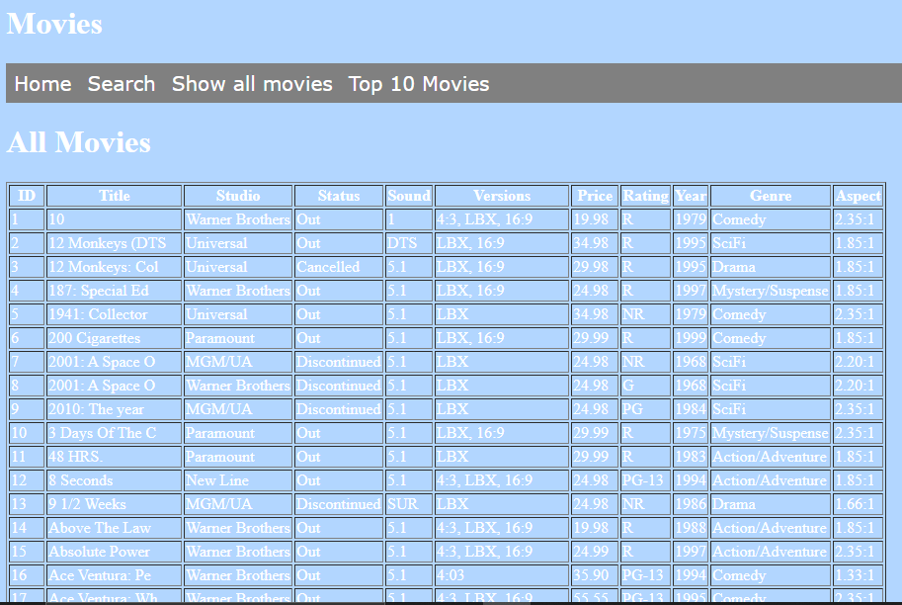

Figure 4.2 – All movies pages

### Bibliography

*360 Logica*. (n.d.). Retrieved from https://www.360logica.com/blog/regression-testing-vs-functional-testing/

*CITE Managed Services*. (n.d.). Retrieved from http://www.citems.com.au/?page_id=84

*Guru 99*. (n.d.). Retrieved from https://www.guru99.com/accessibility-testing.html

*Guru 99*. (n.d.). Retrieved from https://www.guru99.com/compatibility-testing.html

*Guru 99*. (n.d.). Retrieved from Performance Testing: https://www.guru99.com/performance-testing.html

*Guru 99*. (n.d.). Retrieved from Configuration Testing: https://www.guru99.com/configuration-testing.html

*Guru 99*. (n.d.). Retrieved from Security Testing: https://www.guru99.com/what-is-security-testing.html

*Professional QA*. (n.d.). Retrieved from http://www.professionalqa.com/gui-testing-vs-usability-testing

*Software Testing Help*. (n.d.). Retrieved from Localization and Internationalization: https://www.softwaretestinghelp.com/localization-and-internationalization-testing/

*Techopedia*. (n.d.). Retrieved from UAT: https://www.techopedia.com/definition/3887/user-acceptance-testing-uat

*Wikipedia*. (n.d.). Retrieved from System Integration Testing: https://en.wikipedia.org/wiki/System_integration_testing

### Glossary of Term

**System Integration Testing (SIT)** – This is a software solution designed to deliver instructional content.

**User Acceptance Testing (UAT)** – This is last phase of the software testing process. During this phase, actual software users test the software to make sure it can handle required tasks in real-world scenarios, according to specifications.

**Graphic User Interface (GUI)** – This is a form of user interface that allows users to interact with electronic devices through graphical icons and audio indicator.

**Structured Query Language (MySQL)** - This is an open-source relational database management system. Its name is a combination of “My”, the name of co-founder Michael Widenius’s daughter, and “SQL”, the abbreviation for Structured Query Language.

**Hypertext Mark-up Language (HTML)** – This is the standard mark-up language for documents designed to be displayed in a web browser.

**Hypertext Pre-processor (PHP)** – This is a general-purpose programming language originally designed for web development.

## Analysis documentation

### CITE Business Rules for Software Development

CITE has their own coding standards to tell developers write all code according to the coding standards outlined by CITE. These standards are to ensure that large project can be coded in a consistent style.

### The Common Aspects of CITE Coding Standard:

* Naming Conventions
* File Naming and Organization
* Formatting and Indentation
* Comments and Documentation
* Pointer and Reference Usage
* Testing

The context of the language and client’s requirements will affect the coding standards. Without meeting the standards, the CITE developers will default to the industry standard.

The following “[ISO](#_Glossary_of_Term" \o "International Organization for Standardization )” Standards will cover all the systems and projects:

* “ISO” / ”IEC” / ”IEEE” 12207:2017 Systems and software engineering – Software life cycle processes.

### CITE Managed Service Quality Assurance

CITE Managed Services has actualized a Quality Management System (QMS) containing a mind-boggling set of engineering and managerial activities that guarantee bespoke quality of delivered software throughout the whole work process

### Quality Management Services’ Tasks and Objectives

* Elaboration and execution of methods and guidelines for software development process dependent on industry standards and best practices
* Product lifecycle monitoring to make sure compliance with established processes and guidelines
* Product quality verification and validation to ensure that it conforms with client’ business necessities and expectancy
* Establishment of an efficient teamwork between all project team members

### Comprehensive Approach to Quality

* Quality Planning
  + During the development cycle of each project, CITE Managed Services will gather the suitable sets of standards, regulations, procedures, guidelines and tools in quality plans
* Quality Assurance
  + To ensure that quality standards are being followed and delivered software implemented with client’s requirement, CITE Managed Services has established processes that appraise project performance
* Quality Control
  + CITE Managed Services will measure performance trends to evaluate defective pieces of code and ensure that deliverables are high quality and correct

### Independent QA Department

CITE Managed Services has an independent “QA” department. The “QA” department leads by experienced “QA” engineers who engaged in projects on a committed or an on-demand basis. The division of “QA” engineers will be based on project complexity; they can be rearranged upon requirement. This is giving flexibility to enhance efforts and overall project budget. The “QA” department will responsible for:

* Full-cycle “QA” Testing
* Document and Code Reviews
* Defect Tracking
* Process Monitoring
* Risk Management

### Quality Assurance Life Cycle

The phase of QA life Cycle at CITE Managed Services as below:

1. Initiation and Planning – Project specification analysis, test plan elaboration and team assignment
2. First Review – Initial testing of first development deliverables, refining the test plan and test item (if necessary)
3. Iteration Audits – Ongoing testing of intermediate iterations builds
4. Final Verification and Validation – Final product testing to ensure bespoke quality and readiness for deployment

Despite of that, CITE Managed Services also employ full spectrum of test types to make sure client’s project enjoy in-depth quality assurance:

* Functional and Regression Testing
* GUI and Usability Testing
* Accessibility Testing
* Compatibility Testing
* Performance Testing
* Installation / Configuration Testing
* System / Integration Testing
* Security Testing
* Internationalization / Localization Testing
* User Acceptance Testing (UAT)

### ACME Entertainment Pty Ltd development requirements

* Review and update application to ensure it can be used across all major digital platforms
* Must include multi-platform report to explain the advantages of adaptive and responsive design and what design we choose to use on this application
* Ensure the development of the application can be hosted on the cloud or suitable local server
* Create a testing plan to trace testing result of the application

### Bibliography

*Coding Standards*. (n.d.). Retrieved from CITE Managed Services: http://www.citems.com.au/?page_id=93

*Quality Management* . (n.d.). Retrieved from CITE Managed Services: http://www.citems.com.au/?page_id=84

### Glossary of Term

**International Organization for Standardization (ISO)** – This is an international standard-setting body composed of representatives from various national standards organizations.

**Institute of Electrical and Electronics Engineers (IEEE)** – This is a professional association for electronic engineering with its corporate office in New York City and its operations Centre in Piscataway, New Jersey.

**International Electrotechnical Commission (IEC)** – This is an international standards organization that prepares and publishes international standards for all electrical, electronic and related technologies – collectively known as “electrotechnology”.

**Quality Assurance (QA)** – Is a way of preventing mistakes and defects in manufactured products and avoiding problems when delivering products or services to customers